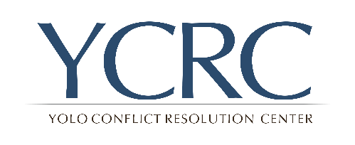 | Yolo Conflict Resolution Center  Phone: (530) 564-2324  705 Main Street, Woodland CA 95695  PO Box 1874 Davis, CA 95617  Email: programs@yolocrc.org
 | Volunteer Application

Date: _____________________________

Contact Information:
Full name:
Mailing address:
Telephone: Email address:

How did you hear about YCRC?
Please indicate your volunteer interests:

Community Mediation Mediator | Restorative Justice Conference Facilitator
Administration/Office Support | Public Relations/Outreach
Development/Fundraising | Other _____________________________

Did you complete either Community Mediation or Restorative Justice Facilitator training with YCRC? (Please indicate which training) ________________________________________________________
If yes, when did you complete your training? _________________ (date)
If you completed either training with another organization, please indicate the organization and the date of training completion:
Organization- ___________________________________________________________________
Training Completed- __________________________ (date)

What interests you about YCRC? Why are you interested in volunteering?

When are you available to volunteer? (Check all that apply)
Weekdays, daytime | Weekends
Weekdays, evening | Flexible

Are you proficient in any languages in addition to English? Yes ___ No___
If yes, list the languages and describe your level of verbal and written proficiency.

Describe any specific skills, abilities, or experience that you bring to this volunteer position.

Other Professional/Business/Volunteer affiliations:

What concerns, if any, do you anticipate about doing this type of volunteer work?

Have you ever been convicted of a felony or, within the last two years, a misdemeanor that resulted in imprisonment? (A conviction will not necessarily disqualify you).
( ) Yes ( ) No
If yes, please explain- ____________________________________________________________________________________________________________________________________________________________________________________________________________________________________________________________

If you are volunteering to be a Restorative Justice Conference Facilitator, do you agree to participate in a LiveScan background check? ______ YES _______ NO

If no, please explain- ____________________________________________________________________________________________________________________________________________________________________________________________________________________________________________________________

My signature below certifies that to the best of my knowledge and belief, the information on this form is true and correct.
Signature of Applicant _____________________________________ Date_____________________

Thank you for applying to be a volunteer with YCRC. We will be in contact with you soon.

